Scenario | User Account | Screenshot
Ineligible Account | BP1100002489@DTEACCEPT.COM | 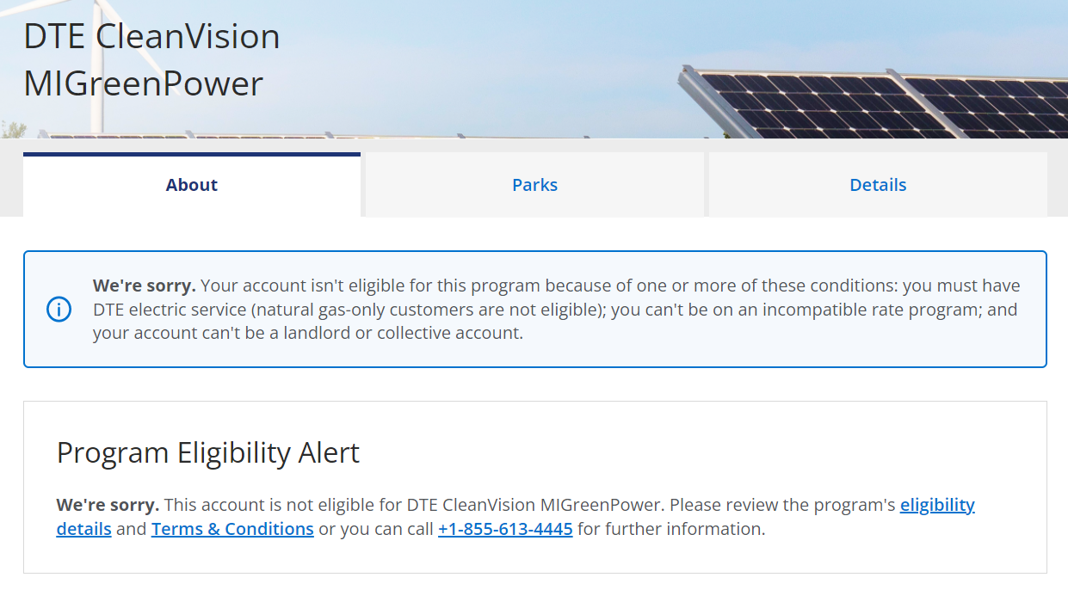
Program Full – No Enrolments  Program Full – Single Enrolments  Program Full – Multiple Enrolments | BP1100002763@DTEACCEPT.COM | 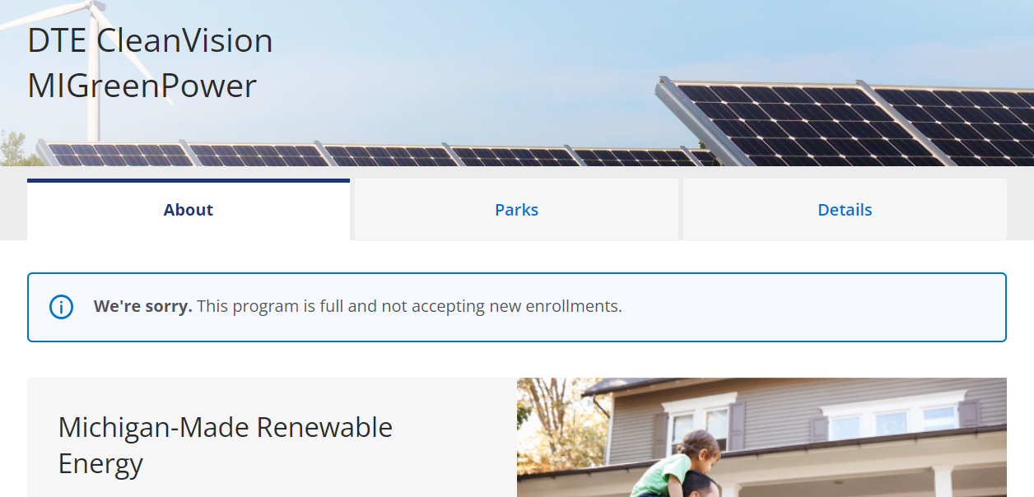  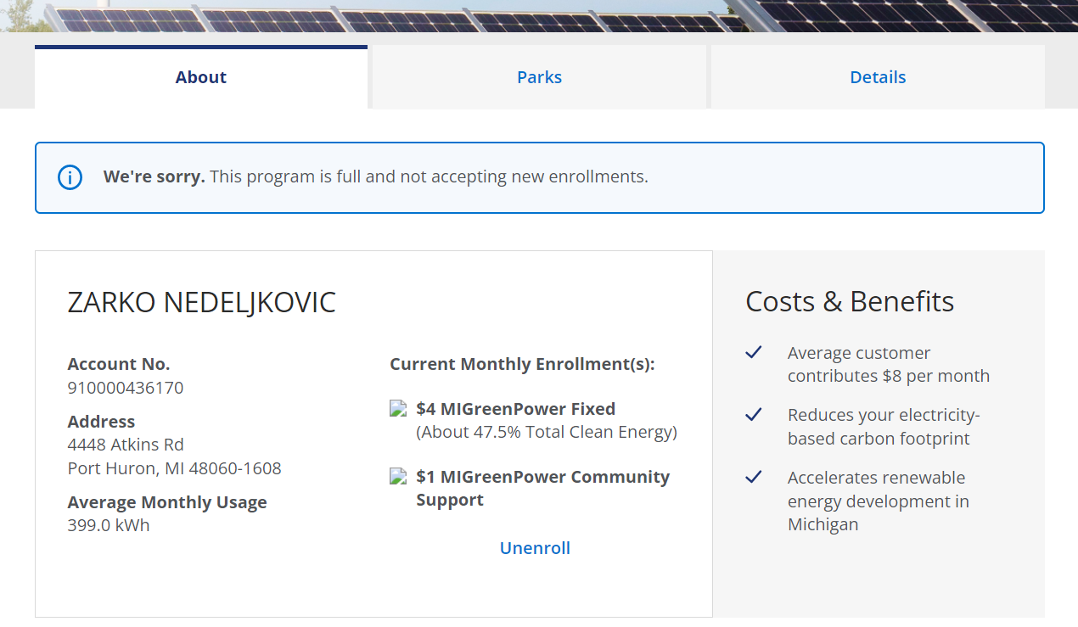  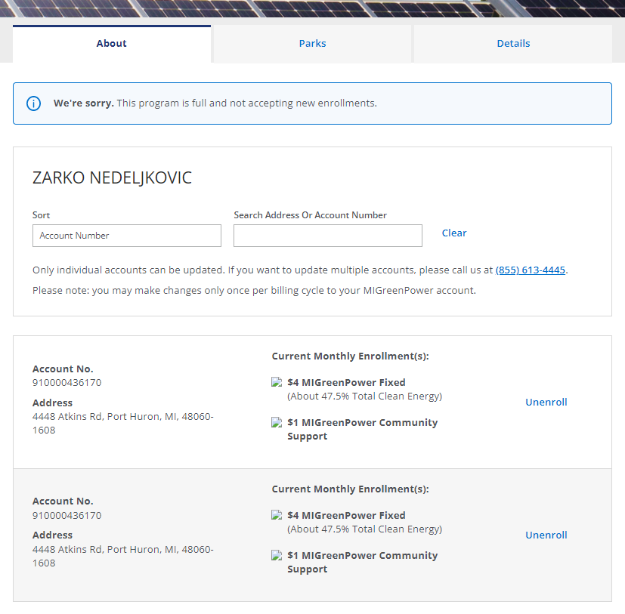
Single Account, No Enrolment | BP1100002691@DTEACCEPT.COM | 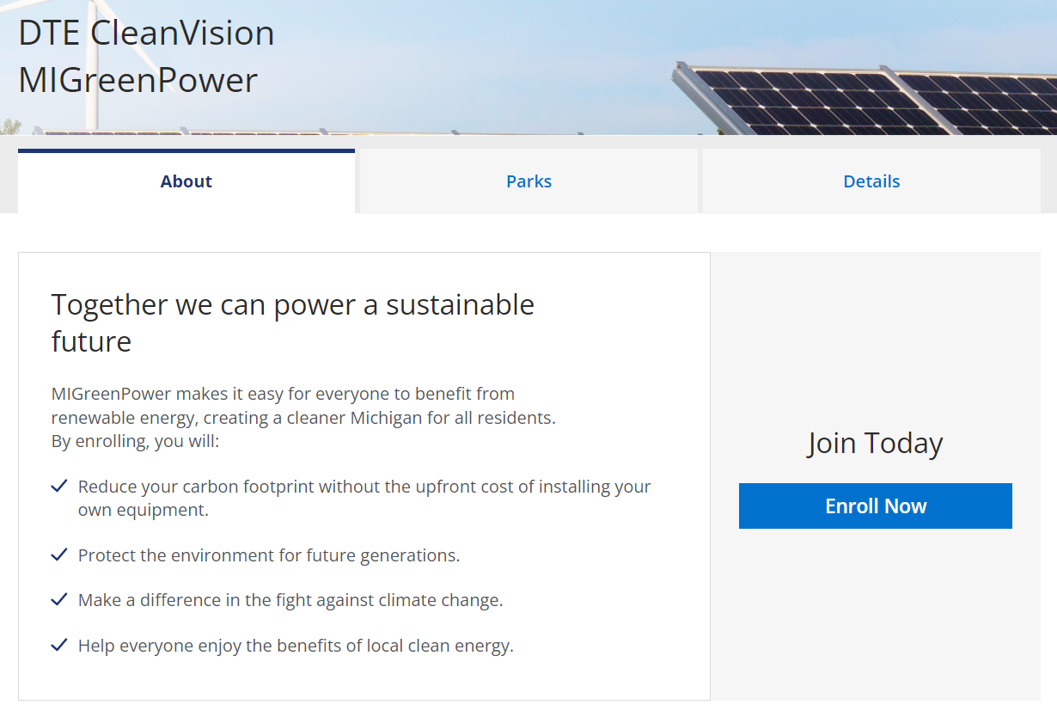
Single Account, Enrolled, Change Eligible | BP1100002759@DTEACCEPT.COM | 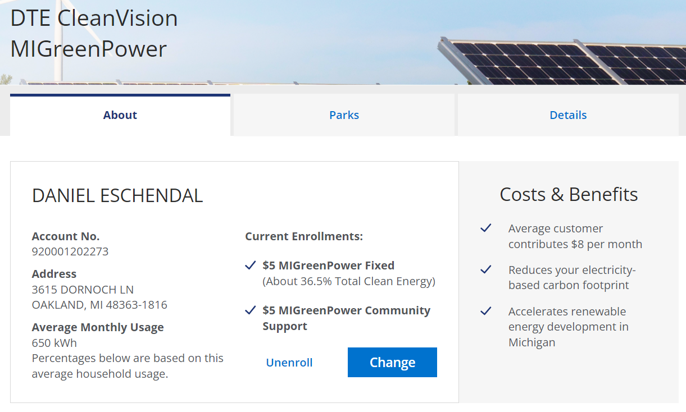
Single Account, Enrolled, Change Ineligible | BP1100002763@DTEACCEPT.COM | 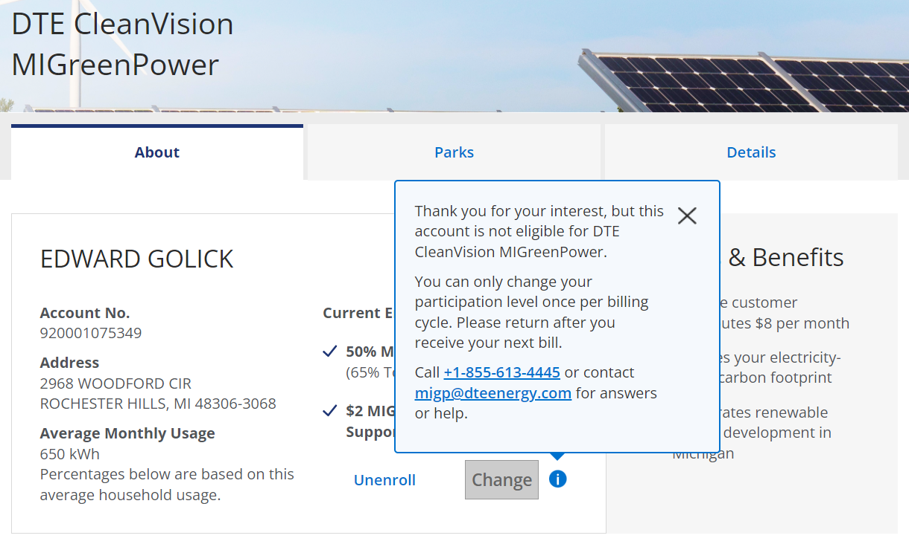
Single Account, Enrolled, Unmetered | BP1100222299@DTEACCEPT.COM | 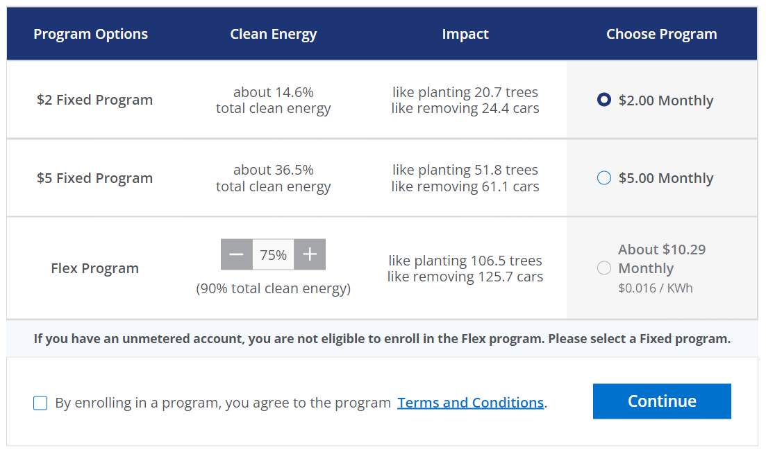
Single Account, Enrolled, Custom Program | BP1100002773@DTEACCEPT.COM | 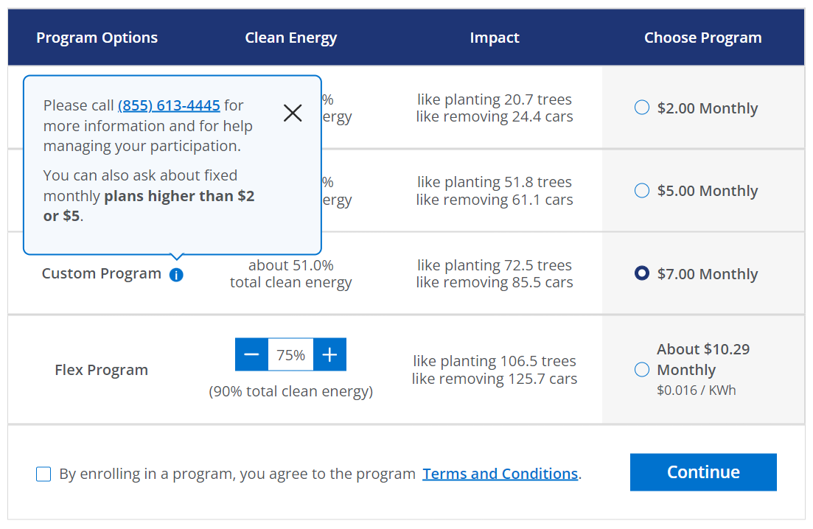
Multiple Accounts, Not Enrolled | BP1100002746@DTEACCEPT.COM | 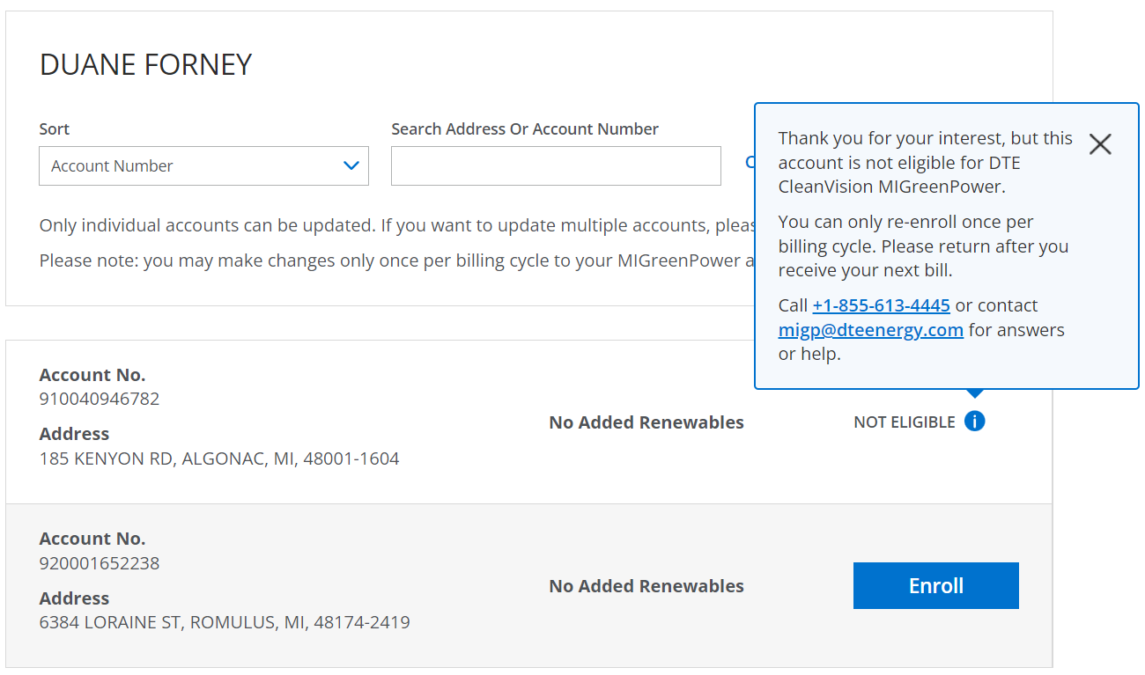
Multiple Accounts (>5 accounts), Mixed Enrolments | BP1100002492@DTEACCEPT.COM | 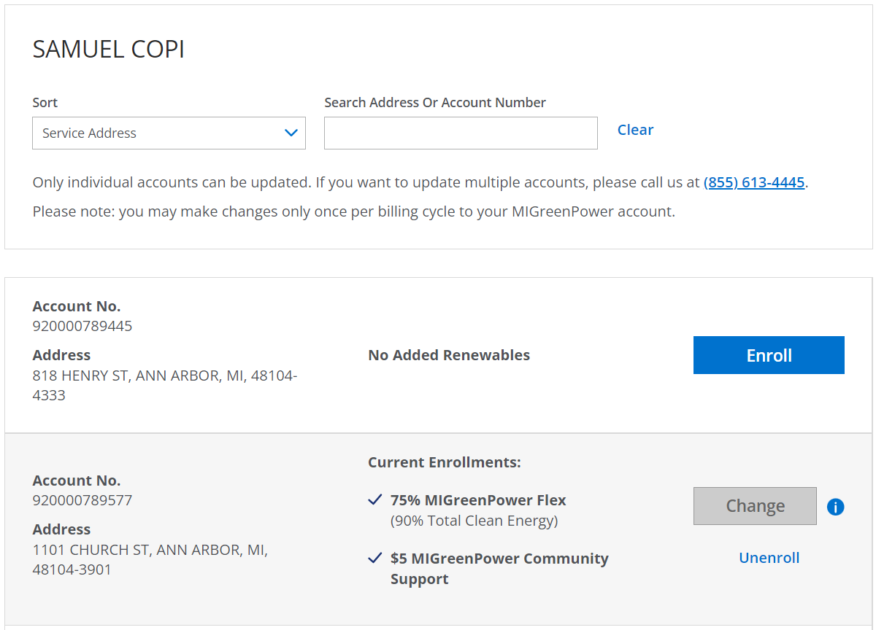
Guest Account | CARDINAL HVC LLC  920004585930  111395410

